

**Readme**

Hello, welcome to the NIAC Specialized Lighting Calculator!

To use this tool, start by pressing the “Click to Begin!” button on either the Exit Sign Calculator or the Exterior/Special Lighting Calculator (as seen below in Figure 1). The program will prompt you to input information regarding how many lights you want to replace, hours of operation, current operating conditions, electricity rates, and a few other questions. As you enter information into each pop-up, the light blue/green area underneath the button will begin to populate. When the routine terminates, savings and payback information will be detailed below. Press the “Clear All” button to clear the populated list and begin another calculation.

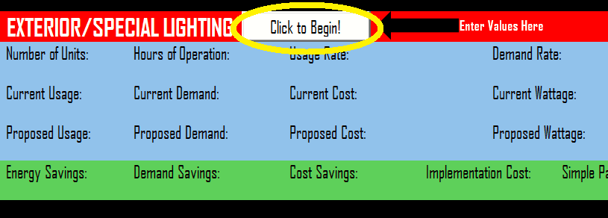

**Figure 1:** Entering Values

**Changelog:**

**V1.1**

* Added support for differing facility input voltages that affect exit sign power consumption
* Added support for up to two different monthly usage and demand rates
* Considers variable unit capital: certain cost discounts for purchasing a certain number of replacement units
* Added sentinel control for nonsensical input
* Added pop-up recommendation advice for interns based on input data.

**Future Plans:**

* Add error checks for all invalid input
* Add a summation tool for total savings and payback for Exterior/Special Lighting Calculator